**The Impacts of Oil Industrial Activities on Climate Change in Southern California**

Name

Course

Date

The oil industry of Southern California is one of the leaders of the region in terms of its negative influence on the climate. Given its past as an oil-drilling country and an oil-refinery hub, this region has been historically associated with high levels of industrial emissions that are equivalent to greenhouse gases (GHGs). These emissions have aggravated global warming and had major effects on ecosystems, human health and safety, and the climate system in the region. That necessitates a discussion and analysis of the consequences that the environment and society as a whole suffer from pertaining to industrial activities and to draw attention to the need for change as well as designing meaningful solutions to address such negative effects.

**Brief History of the Oil Industry in Southern California**

Crude oil production in the United States topped thirty million barrels a day, and Southern California has been the region producing oil since as early as the 1880s. The region is home to some of the nation’s biggest oil refineries and is a vital source of energy for the country. However, this comes at the expensive toll to our environment, whereby the land is used in its almost raw form for production. Lifting and processing of oil as a natural resource emits large portions of CO2, methane, and other greenhouse gases (Shivanna, 2022). Methane, for instance, is also a powerful gas that yields far more heat-trapping ability than carbon dioxide will ever achieve. Even as technology has developed to either reduce emissions or offset them in other ways, the volume of these operations sustains high levels of GHG production in Southern California.

[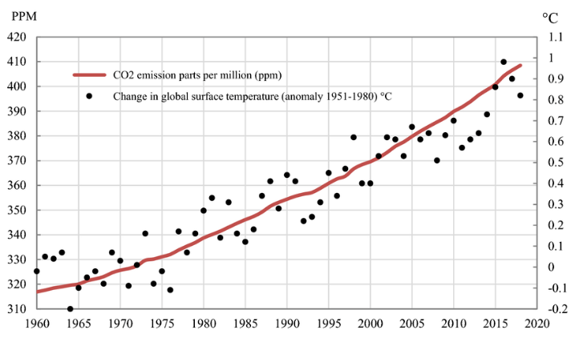](https://link.springer.com/article/10.1007/s10668-023-02926-6) Figure 1: Correlation Between CO2 Emissions and Rising Global Temperatures

[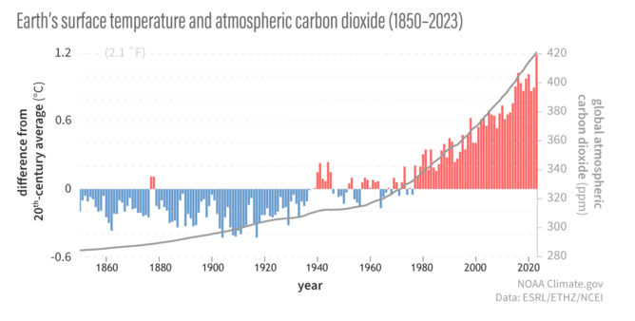](https://www.climate.gov/media/13840)

Figure 2: The pattern of CO2 Emissions against Rising Global Temperatures

**Extreme Weather and Rising Temperatures**

Bad emissions have been cited to have severe impacts, and the most apparent in customer relations is the increase in global temperature. Currently, the average temperature of the upper layer of the earth’s surface has risen by 1.1°C over the century (Abbass et al., 2022). In southern California, heat waves have become more frequent and have increased in severity because of warmer temperatures, increasing deaths during heat events. Hospitals, the elderly, marginalized households, and children suffer most due to the enhanced virus transmission. Moreover, the global warming enhances the effect of droughts on water supply and farming, which is a problem for the arid regions. These environmental changes are not unique; they are part of what is happening throughout the world as industrial emissions alter climate systems.

**Public Health Impacts and Air Quality**

Harmful effects of this oil industrial activity are also the compromise of the air quality in Southern California. The region embraces smog, which is a poisonous cocktail of nitrogen oxides and volatile organic compounds that produce ground-level ozone when exposed to sunlight. The pollution of clean air affects health negatively; most commonly, people develop asthma, lung disease, and other lung-related diseases (Nguyen et al., 2021). Current research also indicates that hot climate states that have become victims of polluted air have high rates of stillbirth and adverse pregnancy outcomes. These pollutants here show how the oil industry contributes to environmental nuisance and public crises as well.

[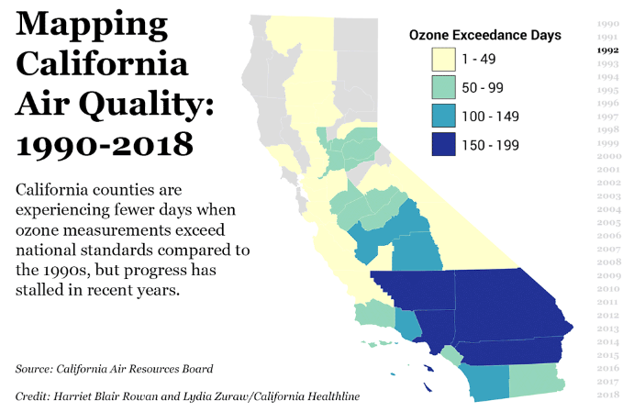](https://californiahealthline.org/multimedia/california-air-quality-mapping-the-progress/)Figure 3: Map of Southern California’s Oil Facilities and Air Quality Index (AQI)

**Social Disruptions**

On the social realm, the oil industry has displaced people and caused change in their living patterns. Persons affected by climate change are creating a shift from the traditional asylum. Heat and exacerbating droughts prompt people and families to evacuate to find more suitable living conditions (Abbass et al., 2022). It is for this reason that Southern California has experienced attendant migration pressure from areas that are experiencing climate stress—an existence that intensifies other sociopolitical vices in the region. This shows how localized pollutions from industries affect the whole global climate, meaning that every aspect counts.

**Ecosystem Disruption and Ocean Acidification**

One of the worst effects of the oil industry on the environment has been its fuel for ocean acidification. Fossil fuels are burned to emit CO2 into the atmosphere, of which 30% is dissolved in water (Mikhaylov et al., 2020). This process reduces the pH of seawater and poses danger to marine life, on which millions depend for food and income. Different chimers in Southern California waters have affected its fishery resources and species like corals. These disruptions all add further evidence to the local community interactions of the oil industry having system-wide impacts on global eco-systems.

The impact that would result from sustained emissions from industries is disastrous. If these tendencies continue, Southern California and its environment will suffer even worse levels and intensity of extreme climate weather occurrences, higher sea levels, and compounded pressure on already vulnerable ecosystems. Furthermore, the effects of the new treatment modality will be experienced most by susceptible individuals and, therefore, perpetuate social disparities (Mikhaylov et al., 2020). Globally, unchecked emissions will result in feedback effects such as melting of polar ice caps and releasing methane from the permafrost, thus opening the flood gates and exacerbating climate change beyond human management.

**Recommendations for Sustainable Solutions**

For overall improvement in handling of industrial emissions, particularly the oil in Southern California, a system change is inevitable. The first way is to establish new tighter emissions standards specifically for the oil industries. Carbon capture and storage (CCS) technology is effective for diminishing the volume of CO2 emissions, and the most successful implementation of the technology is observed in the USA. Switching to renewable power sources, including solar and wind, are other fundamentals that can help to reduce reliance on the base natural substances (Nguyen et al., 2021). On the local level, spending in favor of effective public transportation and energy-efficient construction decreases the amount of oil needed for the people’s daily needs and refines the quality of living standards. These envisage partnerships between policymakers and industry players, as well as support from local communities, in order to bring the change into force.

Southern California’s oil industry best illustrates how industrialization is responsible for climate change. This industry has released increasing levels of greenhouse gases, which have caused global warming, reduced air quality, and affected the ecosystem, resulting in adverse effects on human health and social welfare. But these are opportunities in disguise, as they necessitate action. Today’s actions to protect the environment and consider justice for all mean that humans are able to manage climate impacts in the future. Conflict is inevitable, and the longer companies wait to address it, the more expensive it will get.

**References**

Abbass, K., Qasim, M. Z., Song, H., Murshed, M., Mahmood, H., & Younis, I. (2022). A Review of the Global Climate Change impacts, adaptation, and Sustainable Mitigation Measures. *Environmental Science and Pollution Research*, *29*(1), 42539–42559. Springer. <https://doi.org/10.1007/s11356-022-19718-6>

https://californiahealthline.org/multimedia/california-air-quality-mapping-the-progress/

<https://link.springer.com/article/10.1007/s10668-023-02926-6>

<https://www.climate.gov/media/13840>

Mikhaylov, A., Moiseev, N., Aleshin, K., & Burkhardt, T. (2020). Global climate change and greenhouse effect. *Entrepreneurship and Sustainability Issues*, *7*(4), 2897–2913. <https://doi.org/10.9770/jesi.2020.7.4(21)>

Nguyen, X. P., Hoang, A. T., Ölçer, A. I., & Huynh, T. T. (2021). Record decline in global CO2 emissions prompted by COVID-19 pandemic and its implications on future climate change policies. *Energy Sources, Part A: Recovery, Utilization, and Environmental Effects*, 1–4. <https://doi.org/10.1080/15567036.2021.1879969>

Shivanna, K. R. (2022). Climate Change and Its Impact on Biodiversity and Human Welfare. *Proceedings of the Indian National Science Academy*, *88*(2), 160–171. <https://doi.org/10.1007/s43538-022-00073-6>